LZ Project Space

164 SUFFOLK STREET, NEW YORK

APRIL 16 – MAY 15, 2010

RECEPTION: FRIDAY, APRIL 16, 6-9 PM

THE BACK ROOM BIENNIAL

Amy Greenfield and Debra Jenks CURATED BY LYNN DEL SOL

Marcy Brafman and Michael Zansky CURATED BY DAVID GIBSON

Tom Bogaert and Sally Curcio CURATED BY LINDA GRIGGS

Gabert Farrar and Annysa Ng CURATED BY JENNIFER JUNKERMEIER

Kaeko Shabana and Paul Richmond CURATED BY SAVANNAH SPIRIT

When I first saw the space which was to become LZ Project Space, it made me think of little back rooms in galleries everywhere, which are sometimes offices and sometimes storage facilities, but which always hold the evidence of future achievement. Whether packed up in crates and bubble wrap or hanging just above the gallery director’s desk, what is found in back rooms is the next thing to grace the gallery walls. I thought what if this became a motif for a group exhibition, even a biennial? Using the rarified territory of the back room as a model for organized visions of current and future talent seemed very interesting. I have invited other curators to add to the mix, filling a small space on a side street and making it into a curiosity cabinet of curatorial approaches to the ‘new’ and the ‘next’. What interests me as a curator is the act of translation, and the varieties of presentation which make it possible. All art does this, but group exhibitions do it in a way that makes us super-conscious of how it’s being achieved. I chose to call this exhibition a “biennial” because I wanted to draw the visitor’s attention to the spectacle, or paradox, of looking at art and thinking not just about each work, but the intentions of the curators, who were merely asked to suggest two great contemporary artists. Here they are in their own words:

LINDA GRIGGS: I've always loved exciting looking art that tells a story and then stands alone without it. These two pieces do that beautifully.

In Sally Curcio's piece, "Jack Johnson's Fight" I saw a story about a man who fought every racial convention. For a lesser artist, control of the optical illusion would have been enough. For Curcio it becomes a part of a vocabulary of story telling with Jack Johnson punching holes through the bars of a cage. JM Wilson viewed the work and wrote, “Jack Johnson’s Fight” has the fighter dimly in the background while a grid of white superposes the image like a cage. The intersections of the grid dance with the optical illusion of the colors black and white, appearing and disappearing in the interstices suggesting the ephemeral existence of “color.”

When I first saw Tom Bogaert's piece I admired the beautiful patterning. But a week after seeing it, I kept thinking, why mice? He could have used any shiny, black material; roofing tar, black caulk... I had to contact LMAK Gallery and ask. They replied, "Tom Bogaert's 'Plaine au Mille Souris’ is based on the Malthusian theory that genocide comes forth from poverty and overpopulation. The licorice mice are a national pride of Belgium and considering Europeans’ part in Africa, the symbol is fitting."

I now find myself surprised that the two pieces I've chosen are political. I've never thought of myself as someone interested in political art. For me, this is an excellent example of art's ability to slip around habitual thinking….

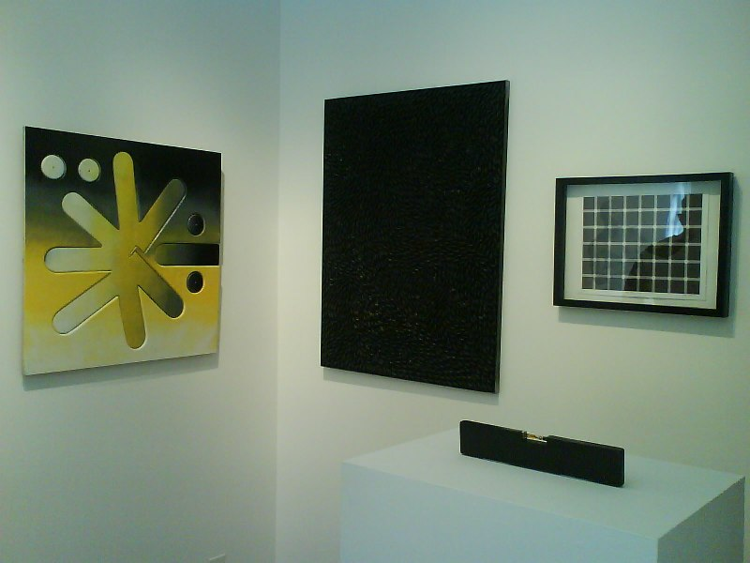
exhibition view - LZ project space - New York, NY 2010

