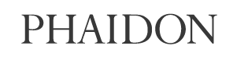
Shane McAdams gets straight to the (ball) point

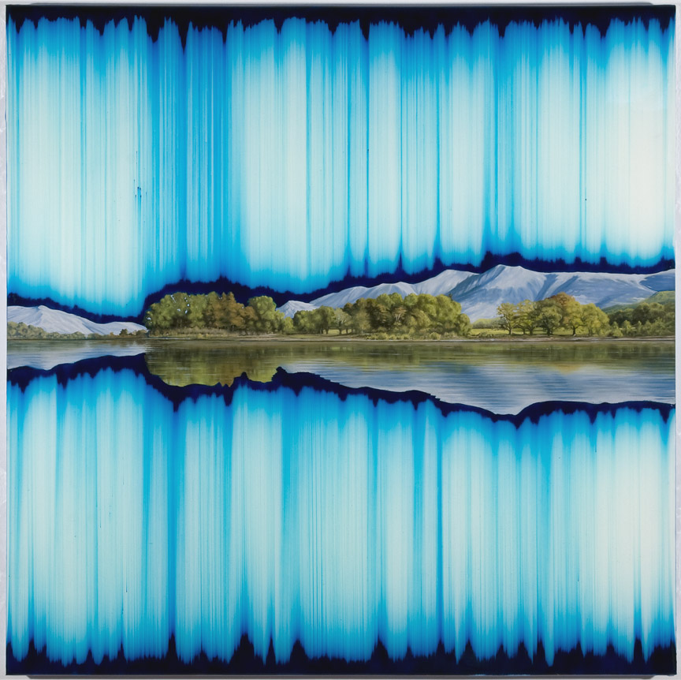

Shane McAdams, Synthetic Landscape 26 (Cyan Symmetry) (2010), Oil, ball point pen and resin on panel, 36 x 36 inches

Brooklyn-based artist Shane McAdams uses ink extracted from ballpoint pens to create paintings inspired by the landscapes of the American southwest, which formed the backdrop to his childhood. Fascinated by the way the elements of wind and rain change and cultivate the natural environment. McAdams also leaves much of the creative process behind his works to chance.
His vivid images on paper are created by extracting ink from pen barrels, heating the liquid, mixing it with solvents and then applying to paper, allowing gravity, wind and other physical forces to dictate the movement of the ink.
An exhibition of his work, shared with fellow landscape-inspired artist Christopher Saunders, is set to open tomorrow at the Allegra LaViola Gallery in New York (January 6 until Fenbruary 4).
The brightly-hued work on display includes works from his 'Synthetic Landscape' series where realistic images of mountains and lakes are squeezed between abstract patterns verging on the psychedelic.
McAdams's first drawings were tracings from road atlases that he collaged into fantasy political maps with fictionalized place names.
"The maps began to function (though I didn’t see it in these terms at the time) metaphorically as well as spatially, as traces of passing time as well as unfolding space," he says. "Likewise, I saw the sandstone towers in the desert as maps of time, recording millions of years of wind erosion that just happened to look like modern art. Like the stratified rock on the Navajo reservation, where I spent much of my childhood, the forms in my work are often analogs to the methods of their creation. They take root in the physical properties inherent within specific, mundane materials such as Elmer’s glue, correction fluid, ballpoint pen ink and resin, whose limits are stretched by subjecting them to non-traditional applications, generating structures whose complexity belies the elegance of their creation. This process reflects the physical forces that are constantly working to fashion and sculpt the natural landscape, and, by bracketing these forms with hand-rendered and conventionalised images, I hope to evoke the duality between the actual and the artificial as it is conveyed through idealised representations of order and beauty."

