SPRING 2013 RTW

Matthew Williamson
by Chioma Nnadi
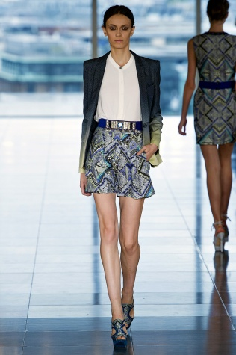
It’s been fifteen years since Matthew Williamson presented his debut Electric Angels collection in a tiny hall on London’s Ladbroke Grove. “I still have people today telling me how much they loved that one,” said Williamson. “It’s funny because we didn’t have the first clue about how to put on a show. I remember turning to my business partner Joe when he told me we didn’t have enough money for chairs and saying, ‘Well the audience will just have to stand.’ ” The designer has come a long way since then, and it was standing room–only on the eighth floor of the skyscraper on Cannon Place.
Williamson circled back to his early years for inspiration, looking to India for the palette and embellishment. “I wanted to reflect that feeling, but not in an obvious way,” he said. He sought the help of New York–based artist Shane McAdams to reconfigure those Eastern influences. Tinged with shades of fuchsia and turquoise, the bleeding blossoms on a pair of cigarette pants recalled the hot-and-cold color combos of Williamson’s first offering. McAdams’s inky ballpoint snowscapes were recast as a tropical mountain range that appeared across the silk shirtdress worn by Cara Delevingne. Her sister Poppy was in the audience with a bevy of other It girls including British-born drummer Tennessee Thomas, recalling the days when Kate Moss and Jade Jagger would wear his signature kaleidoscopic looks. And while the clothes came dripping in trademark ornamental trimmings, Williamson shed the free-spirited riotous abandon of seasons past, and blazers embroidered with mirrors and pompoms had a grown-up ethnic-for-the-office vibe. Granted, an archive as extensive as his is worth revisiting, but in this attempt to recapture a moment, Williamson didn’t entirely connect with today’s cool front-rowers.

