SHANE MCADAMS’ BALLPOINT PEN PAINTINGS
February 3rd, 2012 by
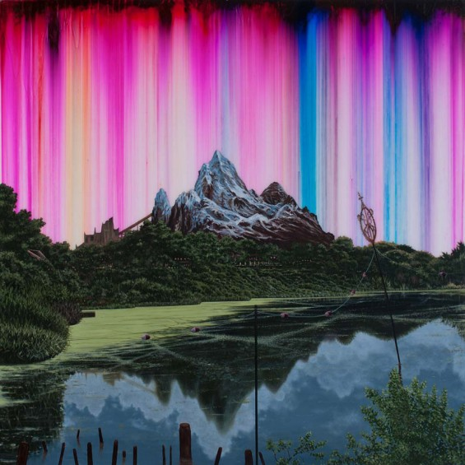

Shane McAdams abstract and landscape paintings are created with a mix of acrylic paint, resin, and your average ballpoint pen ink cartridges. McAdams takes ink from the pen cartridges and pours them onto the canvas surface, blowing on the ink to create the streaks of color. But the experimental nature of his works doesn’t stop there. He then subjects his works to the powerful lights of a tanning salon which cause a chemical reaction to the pen ink which then creates the tie dyed streaked effect.The result is a world unique to McAdams where the natural and the artificial collide to create spectacular visions of a utopian and hyper colored future

