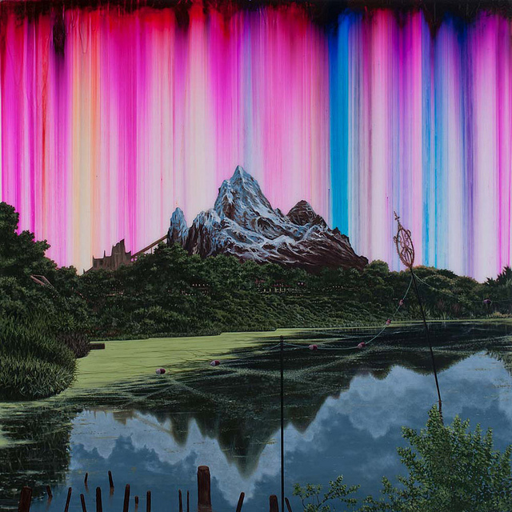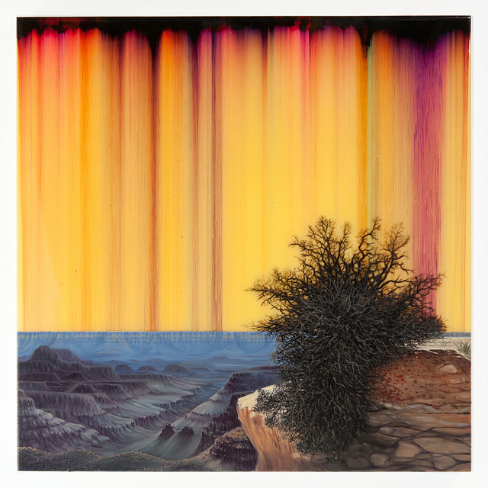

“Synthetic Landscape (Yeti)” 2010 “Synthetic Landscape (Lichen)” 2012

Brooklyn-based artist Shane McAdams combines traditional oils and acrylics with commonplace office supplies such as glue and ballpoint pens, creating illusory landscapes for his Synthetic Landscapes series. Inspired by the geological wonders he witnessed during his childhood on a Navajo reservation, McAdams creates artworks that reveal themselves through layers rendered with different media. He suspends lakes, rock formations and forests among seas of abstraction, allowing us to glimpse at pieces of vistas as if peaking through an opening in the clouds. Take a look at some of his works below, images courtesy of Shane McAdams.

